Day 2

1. Add content in devops.txt (one in each line) - Apple, Mango, Banana, Cherry, Kiwi, Orange, Guava. Then, append "Pineapple" to the end of the file.

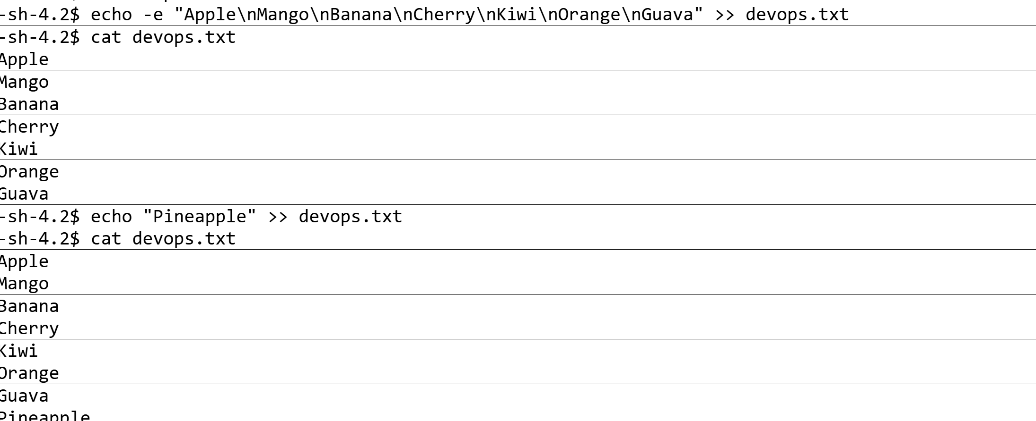

1. Add content in Colors.txt (one in each line) - Red, Pink, White, Black, Blue, Orange, Purple, Grey. Then, prepend "Yellow" to the beginning of the file.

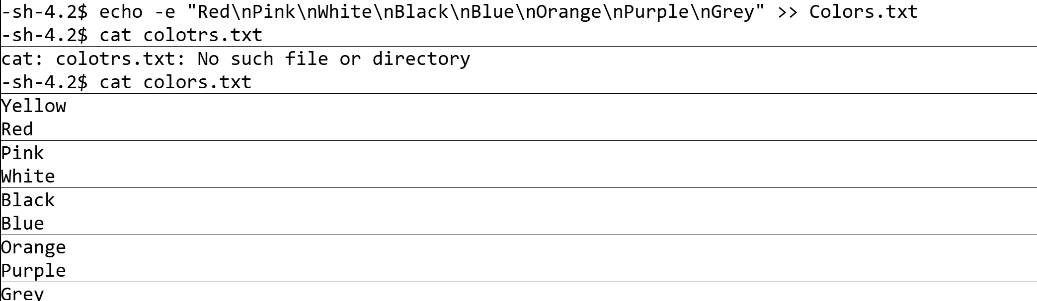

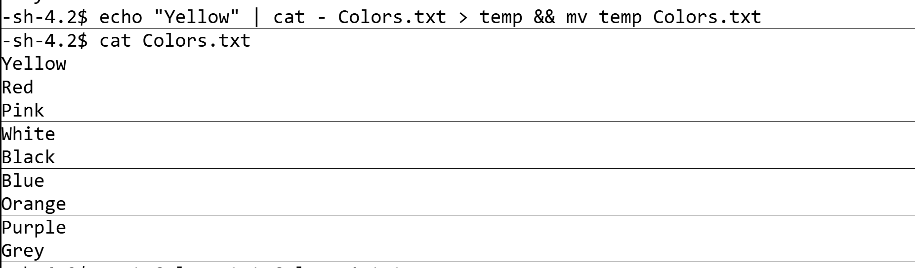

1. Find and display the lines that are common between fruits.txt and Colors.txt

